Daniel Tolbert

1.)
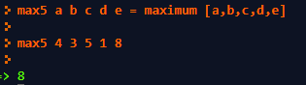

2.)
inset:
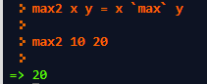
prefix:
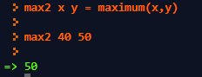

3.)
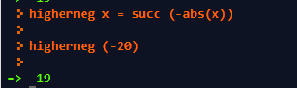

4.)
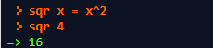

5) Write a function which will return the sum of any two numbers.
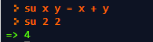

6) Write a function which will find the sum of any four numbers, but use #5's function
to do it.
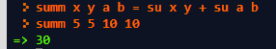

7) Write a function which will calculate your letter grade in a class given a particular
grade% as a parameter: >=90 A, >= 80 B, >= 70 C, >= 60 D, others F

8) Calculate a list that contains 3, 1, 4, 1, 5, 9

9) Calculate the first letter in any string
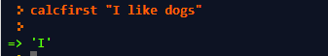

10) Calculate a list that can store this matrix:
3 1 4 1 5
9 2 6 5 3
5 8 9 7 9
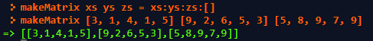

11) Write a function which adds a given parameter to the end of a given list.
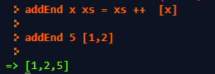
12) Write a function which adds a given parameter to the beginning of a given list.
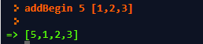

13) What is the tail of "bubba"?


14) What is the init of "bubba"?
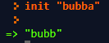

15) What is the head of "bubba"?
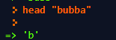

16) What is the last of "bubba"?
